FACS/HSE and Nebraska FCCLA
Listserve Instructions

To Subscribe to the Nebraska Family and Consumer Science/Human Science Listserve (FACS)
- Open a web browser to: http://lists.k12.ne.us/wws/subscribe/FCS
- Enter your email address and request first password
- Follow the instructions sent to your email.
  - Click the link.
  - Update password (instructions bellow)
To Send a Message to the FACS Listserve
- After you are subscribed to the list, send all messages to fcs@lists.k12.ne.us

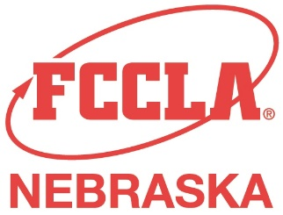
To Subscribe to the Nebraska FCCLA Listserve (NEFCCLA)
- Email Kristin Vest, State Adviser at kristin.vest@nebraska.gov

To Send a Message to the FCCLA Listserve
- After you are subscribed to the list, send all messages to
nde-fccla@listserv.nebraska.gov

Instructions to Change Your Email Address and
Password for FACS Listserve
- Login to http://lists.k12.ne.us/wws
(If you forgot your password, click “Lost Password?” top left.)
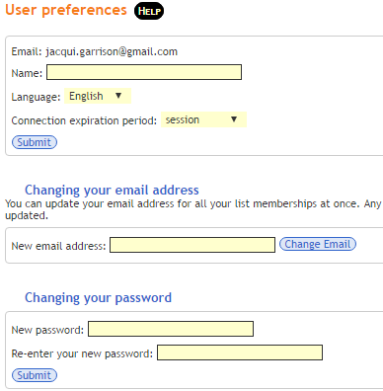
- After you have logged in, click “Your Preferences” link on top of page (black bar)
