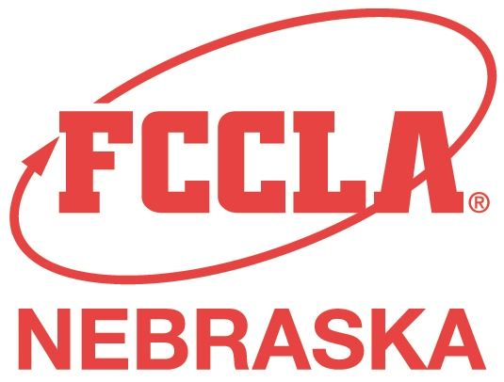
FOR IMMEDIATE RELEASE
Date

Contact Name
Address
City, State, Zip
Phone Number
Email

What was your favorite part of school? Was it homework? Was it relationships? Was it experiences you had in organizations?

Your local Family Career and Community Leaders of America (FCCLA) Adviser (insert name) would like the chance to connect with you and provide positive experiences for the next generation by continuing your involvement in FCCLA.

We are currently seeking Alumni of Future Homemakers of America (FHA) or FCCLA to support and enhance our chapter. There are many ways you can become involved! You can provide assistance with Competitive Events as an evaluator, review student work and provide feedback for growth, share professional knowledge with classes, provide ideas for service projects, as well as many other possibilities!

If you are interested in partnering with the (Insert Chapter Name) please contact (Contact Information).

Family, Career and Community Leaders of America (FCCLA), is a dynamic and effective national student organization that helps young men and women become leaders and address important personal, family, work, and societal issues through Family and Consumer Sciences education. Nebraska FCCLA has more than 3,000 members in 104 chapters across the state.

FCCLA: The Ultimate Leadership Experience is unique among youth organizations because its programs are planned and run by members, and it’s the only career and technical in-school student organization with a central focus on family. Participation in national programs and chapter activities helps members become strong leaders in families, careers, and communities.

